RAFTING SITE PLANNING DOCUMENT | WDD 130

- Site logo:
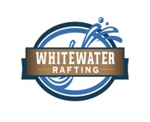

- The Color labels:
. primary-color: Aquamarine #AEF3DE
. secondary-color: Celadon #AFF5BE
. accent1-color: Mindaro #CAED96
. accent2-color: Lavender blush #E7DADA

- The Font labels:
. heading-font: Roboto, Italic
. text-font: Roboto, Sans-serif

- Color Palette URL: https://coolors.co/9bfde0-c2ffcf-caed96-e7dada

